


ALRD Application Checklist
IRA Section 50122: High-Efficiency Electric Home Rebate Program for Indian Tribes
September 2026

VERSION 3
Published September 25, 2026
Modification Note: This version updates text in accordance with the Home Energy Rebates Program Notice 26-3 modifications to the Program Requirements & Application Instructions. This version also makes clerical fixes, including reference corrections.

Instructions:
This is an optional document that is not required by the Administrative and Legal Requirements Document (ALRD). An eligible Indian Tribe may use this checklist as an internal planning document to identify which application requirements are submitted in their Tribal HEEHR Application.
This checklist identifies information and documents required by the ALRD and Program Requirements & Application Instructions (PRAI) and helps Indian Tribes and Program Officers to understand and track what has been submitted.
The Tribal High-Efficiency Electric Home Rebate (HEEHR) Program application deadline is December 11, 2026.
DOE will provide written feedback on submitted applications. The Tribe and DOE will engage in an iterative process of incorporating feedback and finalizing program design to determine and agree upon a proposed program launch date. The Fraud, Waste, and Abuse Mitigation Plan is due at least 90 days prior to the proposed program launch date.

Application Package Checklist
Required Application Documents | Required Submission Date | Target Submission Date | Status
Standard Form 424 | December 11, 2026 |  | ☐ Completed in PAGE
Standard Form 424A | December 11, 2026 |  | ☐ Completed in PAGE
Planned Activities | December 11, 2026 |  | ☐ Completed in PAGE
Budget Justification Workbook | December 11, 2026 |  | ☐ Uploaded to PAGE
Pre-Award Information Sheet | December 11, 2026 |  | ☐ Uploaded to PAGE
Narrative Document* | December 11, 2026 |  | ☐ Uploaded to PAGE
Tribal Council Resolutions and/or final official action(s) by the Tribal governing body** | December 11, 2026 |  | ☐ Uploaded to PAGE
Fraud, Waste, and Abuse Mitigation Plan | 90 days prior to proposed program launch |  | ☐ Uploaded to PAGE
* Certain questions can be deferred to the Tribal Implementation Blueprint and submitted with the Fraud, Waste, and Abuse Mitigation Plan at least 90 days prior to the proposed program launch date.
** As a part of the full application, whether applying individually or as a consortium, Tribes shall provide a “Head of Government Letter,” “Tribal Council Resolution,” or other instrument of appointment by the Indian Tribe’s legally authorized entity and consistent with the Indian Tribe’s laws or customs, documenting their appointment as the sole entity within the Indian Tribe to apply for, receive, and administer the award as authorized by IRA Section 50122 and as described in the ALRD. If a Tribe is using a third-party agent such as a Tribally-Designated Housing Entity to apply for and/or administer the award, this instrument of appointment should name and authorize that entity to act on behalf of the Tribe. For a Tribal Consortium, the governing body of each participating Tribe must authorize its participation by a Tribal resolution and/or a final official action by the Tribal governing body that specifies the scope of the Consortium’s authority to act on behalf of the Tribe. If acting as the lead Tribe of a Consortium, a “Tribal Council Resolution” or “Head of Government Letter” accepting the DE-FOA/ALRD81.041 designation as the lead Indian Tribe for the Tribal Consortium must be submitted. The letter should state that the lead Indian Tribe will apply for grant funding and administer the grant on behalf of all participating consortium Indian Tribes. If using a third-party agent to apply for and/or administer the award on behalf of the Tribal Consortium, the lead Tribe should name and authorize that entity in its letter and explain that it will administer the program for all Tribes in the Tribal Consortium.

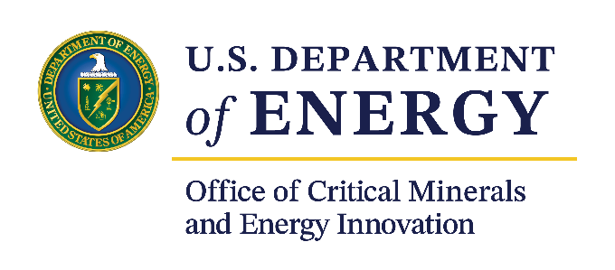

For more information, visit: energy.gov/cmei/
scep/home-energy-rebates-program
September 2026

Per IRA Section 50122, the term ‘‘Indian Tribe’’ has the meaning given the term in section 4 of the Indian Self-Determination and Education Assistance Act (25 U.S.C. 5304).

